Byrne, Alan
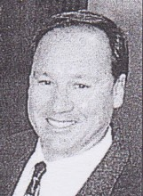
Promoted to District Forester (Training) in Dwellingup 1988. CALM coordinator of organisational learning and development in 2002.

